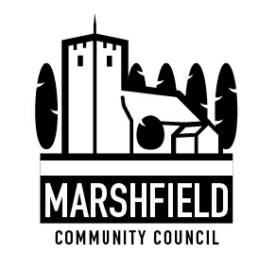
Serving the Communities of Castleton and Marshfield
Chairman: Mrs Catherine Grady
Clerk: Mr G C Thomas 4 Kenilworth Road Newport South Wales NP19 8JQ
Tel: 01633 375812
e-mail:marshfieldcommunitycouncil@gmail.com

Dear Councillor

The next meeting of Marshfield Community Council will be held at the Village Hall, Wellfield Road, Marshfield on TUESDAY 11th February 2020 commencing at 7:30p.m.

Yours sincerely
G C Thomas
Clerk

AGENDA

No. | Item | Time (mins)
1 | Apologies. | 2
2 | Declaration of interests. | 1
4 | Police Matters. | 15
5 | Time allowed for members of public to speak (In line with Standing Order on Public Participation in Meetings). | 15
6 | To confirm the minutes of the Council meeting held on 14th January 2020. | 5
7 | Review of actions arising from the Council Meeting held on 14th January 2020. | 10
8 | To receive a report from the Transport & Road Safety Working Group. | 5
9 | Financial Matters:  1. To receive a payments and receipts update and a bank reconciliation.  2. To receive an update on the review of the Village Hall grounds maintenance contract.  3. To consider a request for a donation to Wales Air Ambulance.  4. Other financial matters. | 10
10 | To review the progress of community projects selected to receive further action. | 10
11 | Planning Matters:  (1) To approve and adopt the comments already returned to Newport City Council for the following planning applications:  MCC 923  Conex 19/1221  Proposal: Construction of two storey dwelling and double garage (resubmission of following refusal of 19/0081).  Site: Red Walk Farm, Walk farm Drive, Castleton, Cardiff CF3 2UY  The Community Council does not wish to make any comments.  MCC 924  Conex 19/0875  Proposal: Erection of Orangery Extension  Site: Tretio, Ty Mawr lane, Cardiff, CF3 2YF  The Community Council does not wish to make any comments.  MCC 925  Conex 20/0010  Proposal: Proposed demolition of existing dwelling and construction of a new replacement dwelling and detached double garage.  Site: Tawstock, 305 Marshfield Road, CF3 2UU  The Community Council does not wish to make any comments.  (ii) Other planning matters. | 5
12 | Correspondence. | 5
13 | Communication:  i) To agree items to be included in the monthly communication to residents in the Marshfield Mail and any posts required to the Community Council website. | 5
14 | Any other business. | 5
The next Council meeting is scheduled to be held on Tuesday 10th March 2020.

