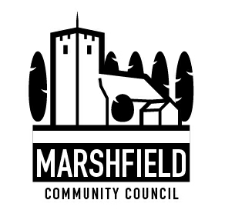
Serving the Communities of Castleton and Marshfield
Chairperson: Mr Alan Chase
Clerk: Mr G C Thomas 4 Kenilworth Road Newport South Wales NP19 8JQ
Tel: 01633 664285
e-mail:marshfieldcommunitycouncil@gmail.com

Dear Councillor

The next meeting of Marshfield Community Council will be held at the Village Hall, Wellfield Road, Marshfield on TUESDAY 8th December 2015 commencing at 7:30p.m.

Yours sincerely
G C Thomas
Clerk

AGENDA
No. | Item | Time (mins)
1 | Apologies. | 2
2 | Declaration of interests. | 1
3 | To confirm the minutes of the Council Meeting held on 10th November 2015 (attached). | 2
4 | To meet Sarah Lyons and Natasha Sullivan-Dungey for Castleton & District Village Hall in connection with a request for financial assistance to improve the Hall. | 20
5 | Police Matters | 10
6 | To consider the appointment of Vice –Chairperson to the Council. | 5
7 | Allotment Matters:  a) Committee Report  b) To consider a review of charges made to allotment tenants. | 15
8 | Leisure Facilities:  To receive an update and decide on the next steps for :  a) Multi-use games area/sports pitch.  b) Marshfield Village Hall extension and landscaping. | 20
9 | Planning Matters:  a) To approve and adopt the minutes of the Planning Committees held on 17th November and 1st December 2015 (attached)  b) To agree a response to Newport CC on the following planning application:  Proposal: Proposed alterations and extension of hotel to include new conference centre and hotel facilities, 10No holiday chalets, access and parking.  Site: St Mellons Country Hotel and Country Club, Newport Road, Castleton, CF3 2XR  c) Other planning matters. | 10
10 | Safe walking to school: Update. | 15
11 | Review of actions arising from previous Council meeting held on 11th November 2015 | 15
12 | Financial Matters:  a) Clerk’s pension.  b) To consider estimates for repairs to children’s play area.  b) Other financial matters. | 15
13 | To consider the Council’s engagement with the public and the options relating to public participation during meetings. | 10
14 | To consider affiliating to Ramblers Cymru | 10
15 | Correspondence. | 10
16 | Consultations | 10
17 | Communication:  To agree items to be included in the monthly communication to residents in the Marshfield Mail and any posts required to the Community Council website. | 5
18 | Any other business. | 10
The date of the next monthly Council Meeting will be 12th January 2016. To be held at Marshfield Village Hall

