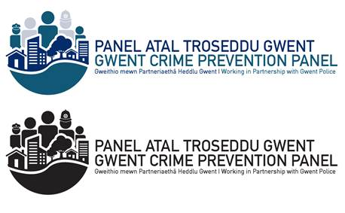

**Crime Prevention Panel**

**Frequently Asked Questions**

**What is a Crime Prevention Panel?**

A Crime Prevention Panel comprises of local willing volunteers from a variety of backgrounds who have an interest in creating communities who care and are passionate about creating a better place to live, work and play.

The Panel brings together local residents who foster a community spirit and a belief in the community's ability to tackle problems, promoting crime prevention and crime reduction.  The members become familiar with local residents who are most vulnerable and do their utmost to look out for them.

In consultation with the local Police, members target local crime problems and are the ‘eyes and ears’ of the community looking out for anything suspicious, submitting intelligence or helping their neighbours as necessary. They are certainly very valuable members of the team.

Each Panel signs up to the formal written Constitution.

**What do Panel Members do?**

Panel members work in partnership with the local Police (Neighbourhood Policing Teams and Crime and Disorder Reduction Officers) and other groups/partners.

The panel meets regularly to discuss crime reduction initiatives and are able to raise issues with the Police. They will discuss and agree a way forward to deal with specific issues. Panel members attend public events throughout the year to offer free advice on home and property security, as well as personal safety.

Panel activities are usually related to particular crime problems in a specific area and activities are agreed in consultation with the local CADRO and Neighbourhood Policing Team.

The Panel members can be involved in:

* Being a visual presence at community and engagement events.
* Distribute leaflets and resources.
* Property mark items.
* Sell crime prevention products.
* Provide a great level of support and offer crime prevention advice to those persons who wish to make their properties secure and personal safety.
* Attend meetings.
* Support door to door enquiries with the Neighbourhood Policing Teams.
* Attend local groups/schools and give talks on crime prevention and personal safety.
* Share intelligence.
* Conduct Community Speed Watch initiatives.
* Conduct Valuable Items on Display initiatives to help reduce vehicle crime.
* Support those who have become victims of crime and promote the services of partner agencies i.e. Connect Gwent, Trading Standards etc.

**Where are the Panels located?**

There are currently 8 Panels operating within the Gwent Police area:

**Blaenau Gwent:** Tredegar & Ebbw Vale Abertillery & Brynmawr

**Caerphilly:** Bargoed & District Blackwood & Risca Caerphilly & District

**Torfaen**

**Monmouthshire:** Magor & Undy Abergavenny - In the stages of implementation

**What Is The Membership of the Panels?**

A Panel will consist of:

* A Chairman
* A Vice Chairman
* A Secretary – To support the group in Admin functions
* A Treasurer
* A Publicity Officer
* A Crime and Disorder Reduction Officer (CADRO) – To take minutes of the meetings and to work closely with the Panel for deployments
* Members

Due to the nature of the work Panel members are involved in, Panel members need to be over the age of 18 years.

**What Is The Criteria For Panel Members?:**

* Panel members are a combination of Neighbourhood Watch Co-ordinators, local business people and members of the public.
* Interested persons are required to undergo the necessary security (vetting) clearance and complete forms.
* Individuals must provide a passport style photograph.
* Upon successful completion of vetting members are issued with an Identification Card. Members must carry and present a valid identification card whilst engaging in panel activities.

**What Funding Is Available To Panels?:**

* Applications for funding for the Panel can be made to the Office of the Police and Crime Commissioner. This is subject to a projected 12 month delivery plan and submission of an audit of the accounts.

**What is the difference between a Crime Prevention Panel and Neighbourhood Watch Schemes?**

The main difference is that Panel members are currently vetted.  They are provided with an Identification Card and information can be shared between them and members of Gwent Police including the local Neighbourhood Policing Teams, Crime and Disorder Reduction Officers etc.  Activities are covered by public liability insurance.

NHW members are not currently vetted.  Therefore only limited non-specific information can be shared.

We are working to align all of the community groups to the Crime Prevention Panels to maximise the opportunities available.

**Further Information:**

If you are interested in joining a Panel or require any further information, please do not hesitate to contact: [Leeanne.Husselbee@Gwent.Pnn.Police.Uk](mailto:Leeanne.Husselbee@Gwent.Pnn.Police.Uk)