Nabod Natur – Nature Wise Comms Pack
Thanks for your interest in Nature Wise. It'd be great if you could help us promote the course via email, newsletters, social media and your website.
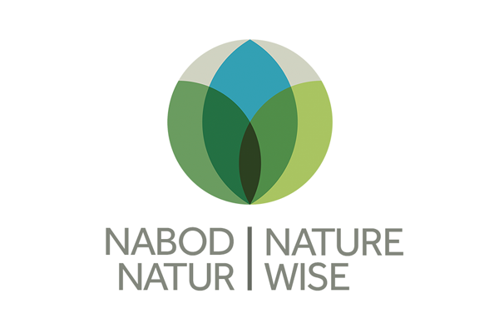
Below is some suggested text for you to adapt and share. Attached is the Nature Wise logo for you to use if you wish. Many thanks for your support.

Newsletter and Website - Suggested Text
Free nature training for Welsh community groups
Up to 150 free online training places are available for community groups in Wales who'd like to protect and restore nature.
Nabod Natur - Nature Wise is a programme which teaches how the natural environment works, the threats it faces, and how we can all help nature thrive.
The organisers, Cynnal Cymru-Sustain Wales, are especially keen to target people who aren’t currently doing environmental work, such as faith groups or those working in the arts or social projects.
Participants will develop action plans for themselves or their groups, using their knowledge for the benefit of wildlife and habitats.
Those successfully completing the course will be awarded a certificate, and follow-up contact will help them maintain progress and share ideas to inspire others.
The courses will run online monthly from October 2021, with participants joining two online sessions with a total time commitment of 5-6 hours.
Paol Stuart-Thomson from the mental health charity Springfield Mind took part in the pilot Nature Wise scheme earlier this year. He said:
“Since doing the course, I’ve started buying used products instead of new, begun topping up my garden bird bath and added an electric motor to my bike so I can use the car less. The course empowers people to change and in today’s world, that is a marvellous result.”

The free places are available thanks to £50,000 funding from the Co-op Foundation.
If you're involved in a community group in Wales, you can sign up for Nature Wise at:
cynnalcymru.com/naturewise-free

Twitter
Free nature training is now available for community groups in Wales!
Nabod Natur - Nature Wise is an online course from @CynnalCymru to help you protect wildlife and habitats.
Find out more at: cynnalcymru.com/naturewise-free
#NatureWise

Instagram
Free nature training is now available for community groups in Wales!
Would you like to take action to protect and restore nature? If you're part of a community group in Wales, you can now register for a free place on Nabod Natur - Nature Wise.
The online course includes two sessions over 3 days, and a total time commitment of 5-6 hours. If you complete it successfully, you'll get a certificate, as well as follow-up contact to help maintain progress.
Find out more at: cynnalcymru.com/naturewise-free
#NatureWise

Facebook
Free nature training for community groups in Wales!
Would you like to take action to protect and restore nature? If you're part of a community group in Wales, you can now register for a free place on Nabod Natur - Nature Wise.
The online course includes two sessions over 3 days, and a total time commitment of 5-6 hours. If you complete it successfully, you'll get a certificate, as well as follow-up contact to help maintain progress.
Find out more and register here: cynnalcymru.com/naturewise-free

LinkedIn
Want to take action to protect and restore nature? If you're part of a community group in Wales, you can now register for a free place on Nabod Natur - Nature Wise.
The online course is run by Cynnal Cymru - Sustain Wales and includes two sessions over three days. If you complete it successfully, you'll get a certificate, as well as follow-up contact to help maintain progress.
Find out more and register here: cynnalcymru.com/naturewise-free
#NatureWise

Please tag us in posts using the following handles:
Instagram - @cynnalcymru
Twitter - @cynnalcymru
LinkedIn - @cynnalcymru

For more information contact:
Bethan Harvey
bethan@cynnalcymru.com

