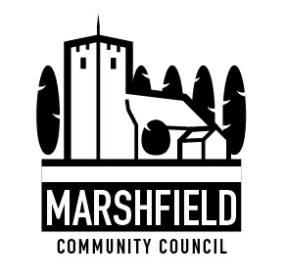
Serving the Communities of Castleton and Marshfield
Chairman: Ms Cath Davis
Clerk: Mr. G C Thomas, 4 Kenilworth Road Newport South Wales NP19 8JQ
Tel: 01633 375812
E-mail:marshfieldcommunitycouncil@gmail.com

Planning and Environment Decisions Wales, 18th September 2022.
Crown Buildings,
Cathays Park,
Cardiff,
CF10 3NQ.

Dear Planning Inspector,

Wentlooge Farmers Solar Hub Development of National Significance
CAS- 01772 – Z5P5D2

Marshfield Community Council (MCC) was involved in the previous submission of the Wentlooge Farmers Solar Hub application for the largest solar development in Wales on the Wentlooge Levels St Brides SSSI.

MCC submitted a response on 11th September 2020 for the DNS / 3216558 then under the Planning Inspectorate, Wales.

In this response MCC drew attention to the objections and concerns of the community we represent; these are still relevant to the resubmitted application PEDW CAS-01772-Z5P5D2.

The proposed solar hub would occupy a large area (approximately 400 acres/ 161 ha) on the Wentlooge Level, adjacent to The Broadway, B4239 coast road, Hawse Lane and the South Wales Main railway line just south of the village and community of Marshfield. This area is very special and important to Marshfield and Castleton residents. The Community has been consulted by MCC; the results have indicated that objections are made for the following reasons:

Important Designations and History
- The development site is adjacent to the Severn Estuary which has an important status as a Special Protection Area (rare and vulnerable birds); Special Area of Conservation (threatened habitats and other species); International RAMSAR Convention on Wetlands of International Importance as a Waterfowl Habitat and European Marine Site.
- The proposed site is an area of open countryside classified as the St Brides Special Site of Scientific Interest and should be protected from habitat loss and destruction. As such its outstanding hand crafted landscape is recognised by inclusion onto the 1998 Register of Landscapes, Parks and Gardens of Outstanding Historic Interest in Wales (CADW).
- ‘The term Historic Landscape is very important and refers to the time/depth present in the physical features of the landscape’ (Rippon SJ). There is a strong historic time-line visible in the landscape from Roman influences, remains of medieval settlements and associated field systems. There is a potential for as yet undiscovered archaeological remains to be present.
- The landscape has a unique, archeologically important and irreplaceable system of ‘Grips’ ‘Reens’ and ‘Ditches’ which will be destroyed by this solar development. The Gwent Levels are one of the best preserved reclaimed landscapes in Wales (www.livinglevels.org). This landscape has seen centuries of stable maintenance of the water courses (Act of Sewers 1531).
- These watercourses demonstrate the best assemblages of aquatic invertebrates in the country, the world’s smallest flowering plant (Wolffia arrhiza), and assemblages of water beetles (Hydrophilus piceus), not found anywhere else in Wales and the reason for the SSSI designation. It is essential these water courses are protected from this development as leaching and other pollutants from the solar panels and the process of construction are likely to enter the watercourses.
- The site area is classified as ‘Green Wedge’ in Newport City Council’s Local Development Plan (2011-2026); this allows for open areas between settlements and is important in maintaining a distinct line between countryside and built areas. The solar development would detract from this aim and extinguish the Wentlooge Level into history by turning it into a brown field industrial site.
- The site is part of the Wentlooge Levels Historic Landscape reclaimed some 1800 years ago by Roman occupiers. The ancient, unique and rare landscape should be preserved for future generations (Well Being of Future Generations Act (Wales) 2015)
- National Resources Wales and RSPB were able to achieve £4 million in Heritage Lottery funding to promote, engage and reconnect people and their communities to the Gwent Levels landscape with the formation of the Living Levels Landscape Partnership. They have succeeded in this mission and the important work so achieved would only be wasted by further development on this precious landscape.
- Protection of the landscape has been deemed so urgent that the Welsh Government has set up a Gwent Levels Working Group chaired by John Griffiths MS.

The proposed Development of National Significance would destroy this rare, unique and ancient landscape of the Wentlooge Levels which is recognised nationally and internationally and much valued by the communities of Marshfield and Castleton who do not wish to lose what little there is left.

Landscape
- The proposed solar development should not proceed as the site is located outside the settlement boundary and is within the open countryside. It occupies approximately 10% of the total area of the Gwent Levels.
- The proposed solar site lies on one of the best preserved historic landscapes in the country which is still drained in the traditional way and wholly used and reclaimed by man since Roman and Medieval Times.
- This historic landscape is archaeologically important as little disturbance has occurred over time. It also lies within a wider locality where it is likely that archaeological remains relating to prehistoric, Roman and Post Roman settlement are present. These could be adversely affected by any ground works required for the development.
- The field and reen structure on the Wentlooge Level is unique in Wales and differs from the Caldicot Levels. The time scale of 40 years for the development will mean the landscape will very likely never return to its present state. The solar development and associated infrastructure will have a permanent affect on the appearance of this ancient landscape. It will change a rural landscape into an industrial one. In-fact, the solar development at Goldcliff shows how deteriorated the landscape has become after a short period of time (2 years).
- Currently, the proposed site is pasture land grazed by cattle, sheep and horses. It should be preserved for food production especially at this time of the Ukraine War and the pressures of future climate change on the availability of food.
- Brexit has also created duress on sustainable food sources so this land is needed for the creation of food to help the country become self sufficient. The scheme would render perfectly good productive agricultural land redundant and cause local job losses in the agricultural industry.
- Wetlands are well known to act as a carbon sink absorbing carbon from the atmosphere; this solar scheme will inhibit the ability of this area to act efficiently.
- There should be an effective use of land at this critical time by focussing large scale solar developments on previously developed sites (brown-field) and non-agricultural land that has no environmental value.

This development remains the industrialisation of a particularly sensitive landscape on a massive and unacceptable scale. The adverse effects of this development substantially outweigh any benefits so on this basis it should be refused.

Flooding
- The elevation of the site area is generally below 10m AOD and is well known to flood. In recent years the community has witnessed local roads and lanes adjacent to the site flooded and impassable for 24 hours or more due to winter rainfall. This has been especially bad on The Broadway; the proposed site of the 160 battery containers.
- The development site floods in winter; it is foreseeable that with current weather extremes this will deteriorate even further.
- The proposed development site forms an important soak away as undisturbed land acts like a sponge, absorbing heavy rainfall. To cover such a large area in solar panels will prevent this function and exacerbate flooding.
- This site will be greatly affected by splash erosion issues arising from the concentrated run off of rain from the impervious surface of the 250,000 or more solar panels on the site. Micro-gullies so formed will route the water into the already overburdened drainage system.
- The increased flooding attributed to the solar scheme will affect local residents, damaging properties, causing roads to be closed, disrupting traffic, commerce and everyday life. When homes become flooded it is a reality for the community that flood insurance will become unavailable to house holders.
- Flooding also occurs as a result of the elevation rise into the village of Marshfield and Castleton escarpment; the flood burden is increased by the runoff from this higher ground onto the flood plain as well as from rainfall and high tides.
- An application for a solar development at Peterstone Wentlooge (13/0223) in recent years was refused citing ‘flood risk’ as the reason for the refusal.
- The battery containers will be built up on mounds of earth as at the Goldcliff solar development. This will cause a visual intrusion on a flat landscape, a significant harmful effect on a sensitive character landscape.

This solar development is being sighted in the wrong place; it should be placed on a brown-field site or even better on the roofs of new build houses.

Size and Scale
- The Wentlooge Farmers solar development will be the largest in Wales and one of many applications now heading for the Gwent Levels SSSI’s. It will dominate the landscape and will be seen from many miles around especially from the Wales Coastal Path and from both the A48 and A48M
- The size dwarfs the local population settlements and is approximately 205% larger than the size of all the villages of Castleton, Marshfield, Peterstone and St. Brides combined.
- The solar site is approximately 161 hectares; Marshfield is 49ha, Peterstone 5.3ha, St. Brides is 10ha and Castleton is 14ha. It will be approximately 328% bigger than the village of Marshfield; this is a great concern to the community council as it will dominate the area.
- The development is taking up a significant amount of land and will be overbearing to the local area and community and will distract from what is an open countryside space as it will be visible from all sides.
- Since the 1960’s there has been a great pressure to develop the Wentlooge Levels especially from the Cardiff boundary and much has been lost. This part of the Gwent Levels has been gnawed at from both ends with many unauthorised developments in between.
- If the Cardiff Parkway Train Station at St Mellons proceeds along with this application then the Wentlooge Level will be assigned to the history books forever.
- The ‘temporary period’ of 40 years is a lifetime for some. After this length of time the land beneath the solar panels will be in a very poor condition. A study by scientists at Lancaster University found that a microclimate beneath the panels altered the temperature by lowering it by as much as 5 degrees centigrade affecting plant growth.

Habitat Loss
- When thousands of solar panels are built in undeveloped natural areas, the panels crowd out wildlife and destroy their habitat; protected species will become increasingly marginalised. This site is ecologically rich with rare and endangered wildlife; a number of European Protected Species are confirmed as being present including, voles, dormouse, grass snake, some bat species, otter and great crested newt.
- This area is much valued visually and attracts many visitors to the area like walkers, runners, cyclist, horse riders, bird watchers and tourists and many more with caravans and tents who seek recreation and enjoyment from this amazing place.
- An internationally recognised Biodiversity Action Plan (BAP) species are present at the application site represented by the shrill carder bee (bombus sylvarum) a UK priority species’ (LLLP July 2022 Our Vision for the Future)) The physical presence of approximately 250,000 solar panels will inevitably displace the current wildlife and devalue the present habitat. The compensatory area is inadequate and a very poor substitute for the proposed development site.
- It is recognised that large solar energy developments have considerable environmental drawbacks, ‘Large utility-scale solar panels take up a lot of space, which can result in environmental degradation and habitat loss. Solar farms that cover a large amount of land are likely to have an impact on the local fauna and flora, particularly on birds. Solar farms also inhibit local vegetation growth and damage agriculture. Unlike wind energy, solar panels aren’t able to share the land they occupy with other uses’. July 26, 2019 Didem Tali
- The Gwent Levels are increasingly being targeted by solar scheme developers; several have already been sited on the Caldicot Levels. The accumulative effects of all these developments are crowding out wildlife by destroying their habitat and the precious landscape.

Solar Panels
- Solar panels are known to be inefficient and the reason why they need to cover such a large area. On a sunny day they are noted to be only 21% efficient – the developer in fact stated that on average theirs are only 14% efficient. Renewables as it turns out are particularly difficult to renew.
- Solar panels only work while the sun is out; at night and overcast days can interrupt supply. Germany’s increasing reliance on solar and wind almost led to blackouts in June 2019 (Mackinsey Report).
- The rare earths Lithium and Cobalt, used in solar panel production, are difficult to extract and refine causing environmental damage and population harm in the places they are mined like the Democratic Republic of Congo and Chile (Alan Little BBC World Service 2022) – ‘Green Energy, Some Inconvenient Truths’.
- An environmental downside to solar technology is that it uses many toxic materials during manufacture (hydrochloric acid, sulfuric acid, nitric acid, hydrogen fluoride, 1,1,1-trichloroethane, acetone,)
- They also contain hazardous materials harmful to public health and the environment such as Arsenic (Gallium Arsenide) and Cadmium Telluride. Lead is known to leach from the panels as they age and degrade. Articles describe how the panels are difficult to recycle, many parts ending up in land fill where chemicals leach out into the environment.
- Solar panels are known to last approximately 20 years, unless they breakdown sooner. In the Wentlooge Farmers Solar Hub, approximately 250,000 will be sited which will have to be renewed several times over in 40 years. This means over 500,000 will be used in the lifetime of the development - some parts of which will be going to landfill.
- Solar panels are known to be dangerous to birds as many fatalities occur around large scale solar developments. Scientists believe birds mistake the glare from solar panels for the surface of water and swoop in for a landing with fatal results. It is also known that certain insects lay their eggs on the panels believing them to be water with the same devastating consequences.

Wentlooge Farmers Solar Hub has the potential to poison and destroy the ancient landscape of the Wentlooge Levels and leave it devoid of the precious ecology it is so well known for.

Construction Nuisance
- Large numbers of construction traffic will impact on the communities of Marshfield and Castleton. Both villages already experience high volumes of heavy goods vehicles using Marshfield Road where a primary school is situated. A resident from Goldcliff states ‘large lorries thunder in and out on a regular basis also carving up the roads, absolute nightmare’ when that solar development was under construction.
- The local road surfaces are already in poor condition and the extra traffic needed for this large construction project will cause more damage.
- The community will suffer inconvenience from the noise generated from the site when piling the panels in place, and general heavy plant noise.
- The construction of solar energy power plants can pose hazards to air quality. Such threats include the release of soil carried pathogens and results in an increase in air particulate matter which has the effect of contaminating watercourses.
- Light pollution in the open landscape from the security lights will have a major impact on nocturnal animals and the residents near the site.

Visual Disturbance
- It is well known that any shiny surface that reflects light can cause a safety risk to vehicle drivers when reflecting sunlight especially a large bank of solar panels. The panels facing south-west on the Broadway Road will be particularly troublesome from glint and glare issues and have the potential to cause road traffic accidents.

Noise and Fire Risk

Fire is a great risk as there are at least 160 battery containers proposed that will store the lithium-ion batteries which have been known to spontaneously ignite in other schemes. Lithium-ion batteries have been found to fail by ‘thermal runaway’ (University of Kent 2021). This is a chain reaction where overheating can occur in a single faulty cell which can then spread to other cells nearby. This releases energy or ‘battery fires’ which do not need oxygen and are uncontrollable. Toxic gases (hydrogen fluoride) and flammable gases (hydrogen, methane, ethylene and carbon monoxide) are released into the atmosphere to form a toxic cloud that could drift over our villages and pose a danger to our residents.
- The development will cause a humming noise which comes from the inverters (60dB (large air conditioner)) during the day when light photons are converted to electric currents. This will be audible to the community above the ambient background noise due to the massive scale of the development. They can also make loud cracking noises when needing maintenance which will scare wildlife.
- Transformers will also make noise (core, coil and fan noise) and the cooling fans which are mounted outside the transformer can be a significant source of noise.

The above drawbacks of solar renewables have the potential to cause significant nuisance to our community and real danger of a poisonous gas escape and fire.

Visitors and Tourism
- Marshfield and Castleton see significant numbers of visitors to the area. An extension of the wider important tourist industry in Wales. Visitors come to seek out the history and beauty of the landscape. The proposed site is approximately half a mile from the Severn Estuary and supplied with many public footpaths and the Wales Coastal Path. A solar scheme will spoil the area for walkers and bird watchers. No amount of screening will hide this development
- During the Covid Pandemic local members of the community were very grateful to have the countryside on their doorstep. Rural lanes, footpaths and cycle ways (route 88) were much used and the local community found great comfort in the peace and quiet of the countryside and nature so near, within walking distance. This will no longer be possible especially during construction.
- This area attracts many visitors from the nearby cities for respite in the open countryside. Walkers, runners, cyclists and the rest will experience great disturbances if this development is allowed to proceed especially during the construction phase; inevitably there will be those who will not return.

Arguments will be made that with the current energy crisis Britain; Wales needs to be more self- sufficient in terms of energy however the same logic can be applied to food production.

What will happen, when the solar scheme is decommissioned after the 40 year lifespan? Will the costs be passed on to the local council and tax payer? Or will the site become a brown-field area vulnerable to further industrial development? It is inconceivable that it would ever return to its current condition.

The Community
The communities of Marshfield and Castleton see little benefit from this solar scheme. Other solar developments on the Gwent Levels have used foreign companies for the construction work so no jobs or employment benefits will be forthcoming. The communities face a lengthy time of disruption from construction activities, traffic, noise, and roads surfaces destroyed.

Ministerial Statements Supporting Protection of the Gwent Levels
- The First Minister, Mark Drakeford MS, shelved proposals for the M4 Relief Road in part due to the serious destruction of the Gwent Levels SSSI’s stating;

‘I attach very significant weight to the fact that the Project would have a substantial adverse impact on the Gwent Levels SSSi’s and their reen network and wildlife, and on other species, and a permanent adverse impact on the historic landscape of the Gwent Levels.’
(June 2019)
Also,

Julie James MS, Welsh Government Minister for Climate Change released a written statement;

Taking Action to Better Protect and Manage the Gwent Levels. (1st July 2021)

She includes in her statement:-

- ‘valued recreational asset by both locals and visitors alike’
- ‘some difficult choices around the location of renewable energy projects’
- ‘Welsh Government convened a Gwent Levels Working Group chaired by John Griffiths MS to explore how the levels could be better protected’
- ‘Additional planning guidance across the three local authorities involved to better enable the right developments in the right place to avoid further biodiversity and landscape impacts on the Gwent Levels’
- ‘Our work on the Gwent Levels is just part of a wider response to the climate change and nature emergencies in Wales’
- ‘The Nature Recovery Action Plan for Wales was refreshed with our partners at the end of 2020 to take into account the growing evidence around the scale of biodiversity loss and ecosystem damage’
- ‘I hope members of the Senedd will welcome the progress being made in the protection and enhancement of the Gwent Levels and will support us in expanding this approach to safeguard Wales’s rich natural heritage for present and future generations.

Marshfield Community Council recognises that there is a climate emergency and understands the need for renewable energy however, there is also a nature and biodiversity crisis where the protection of the Wentlooge Levels environment is also an emergency as there is not much left. It has been highlighted here that the environmental disadvantages of solar energy outweigh any benefits. Habitat loss, alteration in land use, exposure to hazardous materials, and the pollution of soil, air, and water resources is too high a price to pay. There are no benefits to the local community from this development; therefore, Marshfield Community Council urges the Planning Inspector to refuse this application.

Yours faithfully
G C Thomas
Clerk to Marshfield Community Council

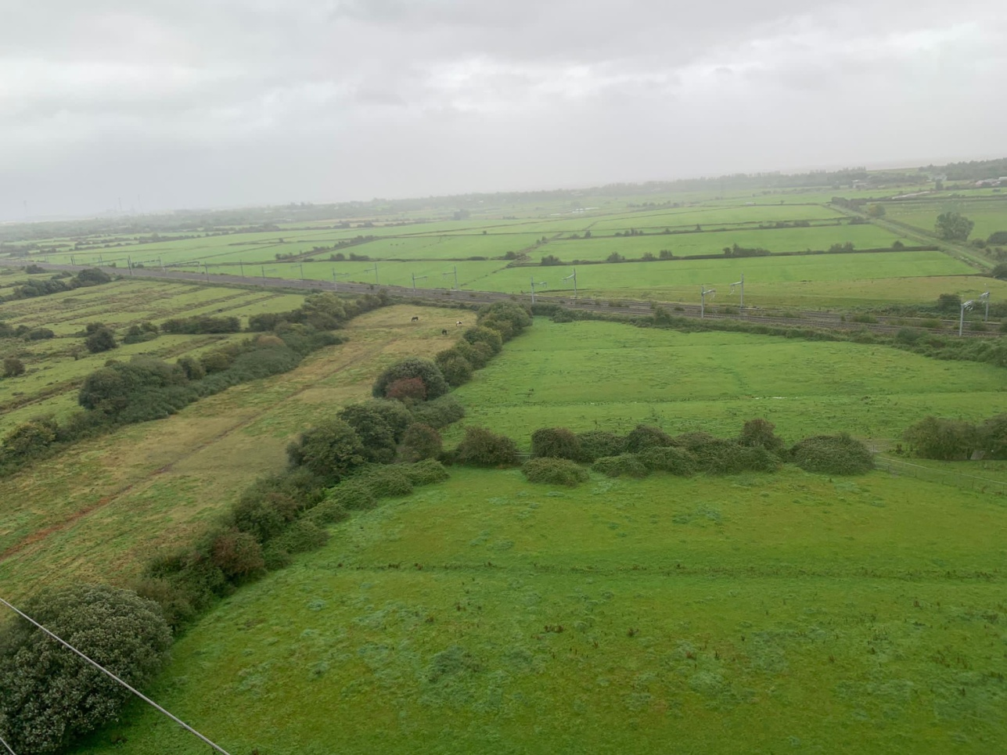
The Wentlooge Farmers Solar Hub; all the fields in the photograph will be covered
in solar panels south of the railway line as far as the eye can see.
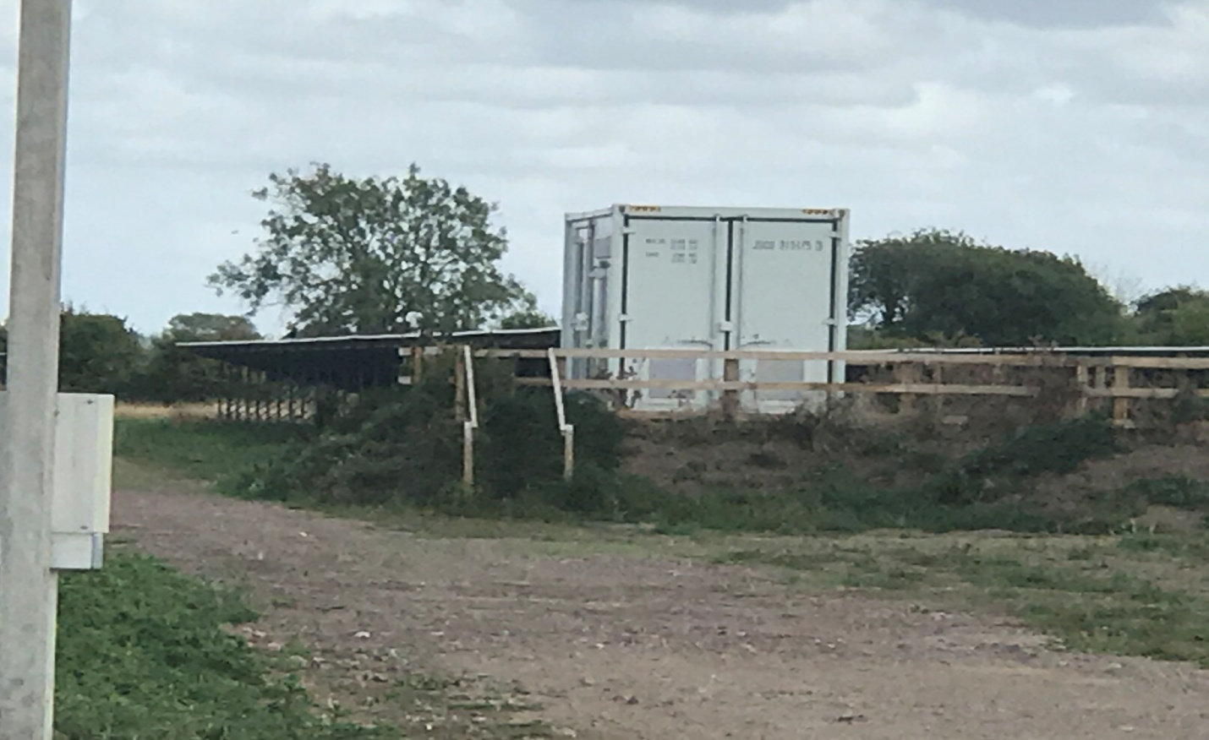
Battery container housing on earthen bund Chapel Lane, Goldcliff 7th September 2022 -
Llanwern Solar Development

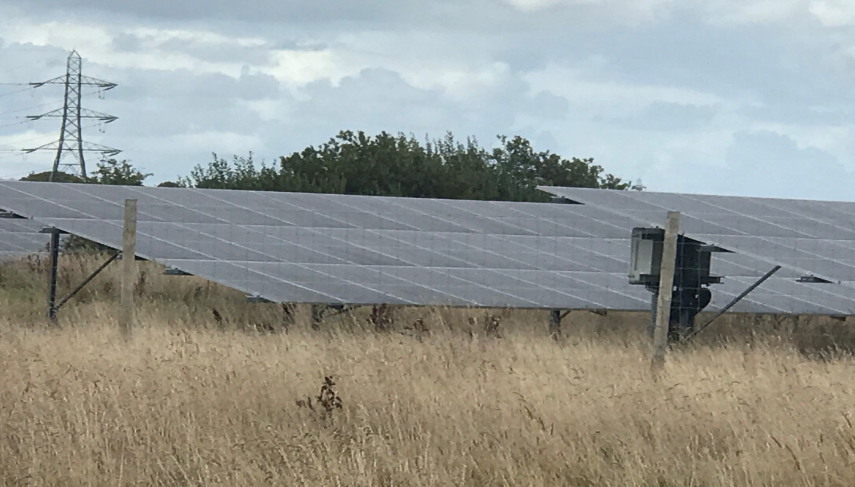
Llanwern Solar Scheme, Goldcliff 7th September 2022 no screening to solar panels

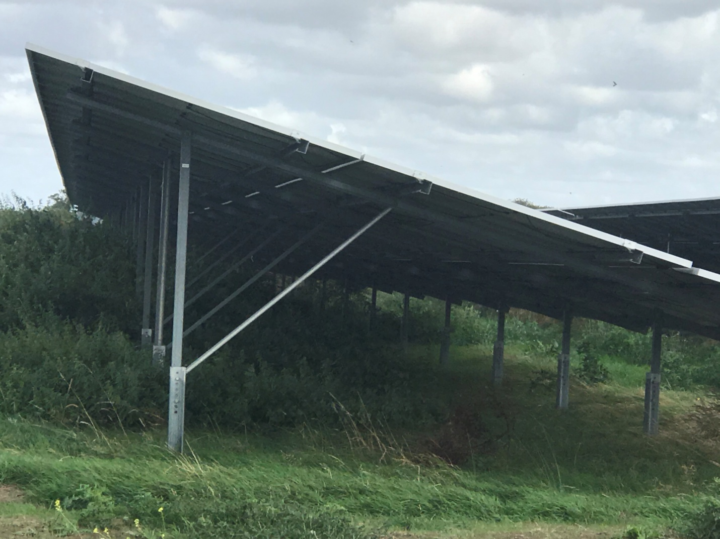
Llanwern Solar Development 7th September 2022, Chapel Lane, Goldcliff.
Image shows shading under the solar arrays and lack of vegetation.
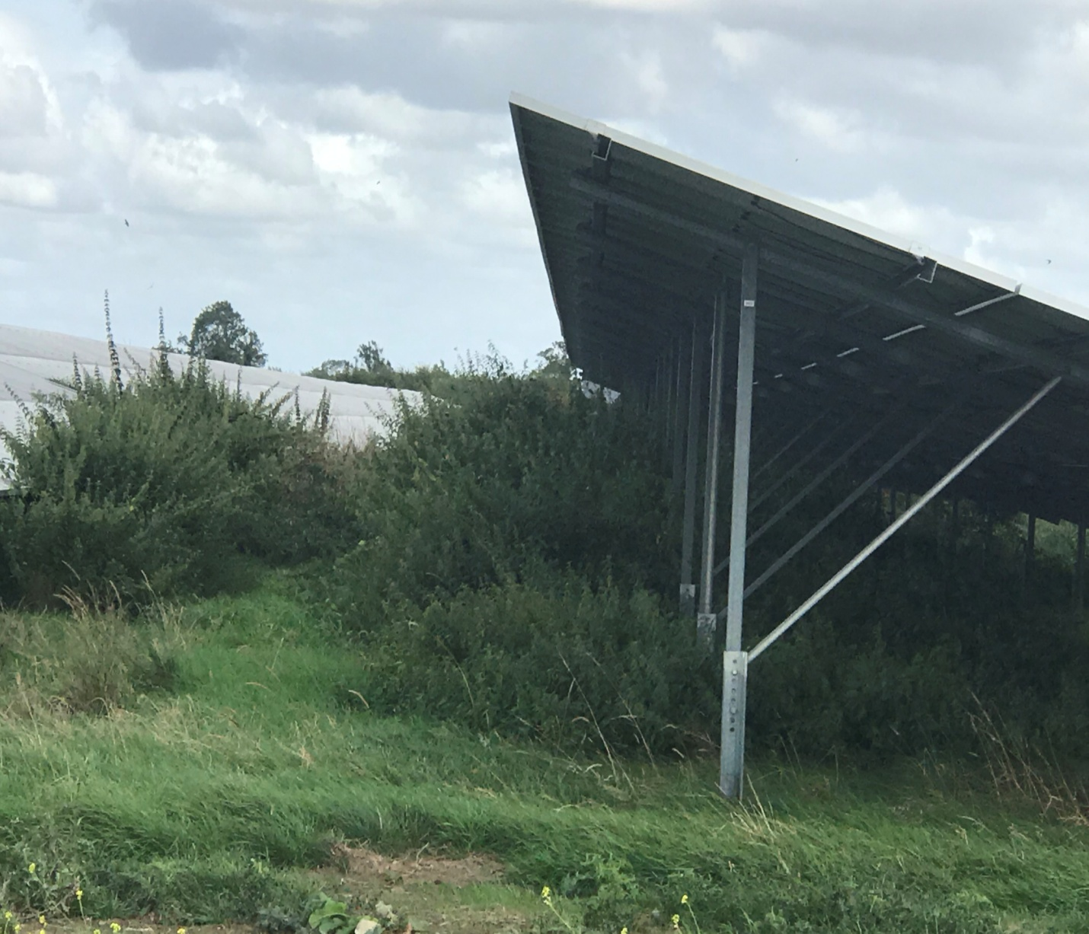
Llanwern Solar Development 7th September 2022, Chapel Lane, Goldcliff.
Image shows poor maintenance of the site, weeds left to grow and no wild flowers.

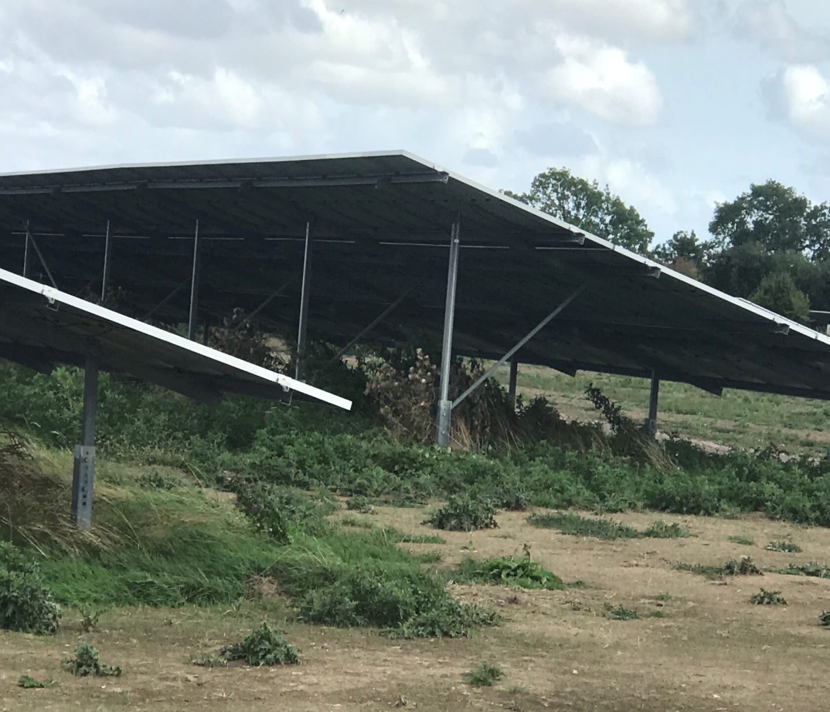
Llanwern Solar Development 7th September 2021, Chapel Lane, Goldcliff.

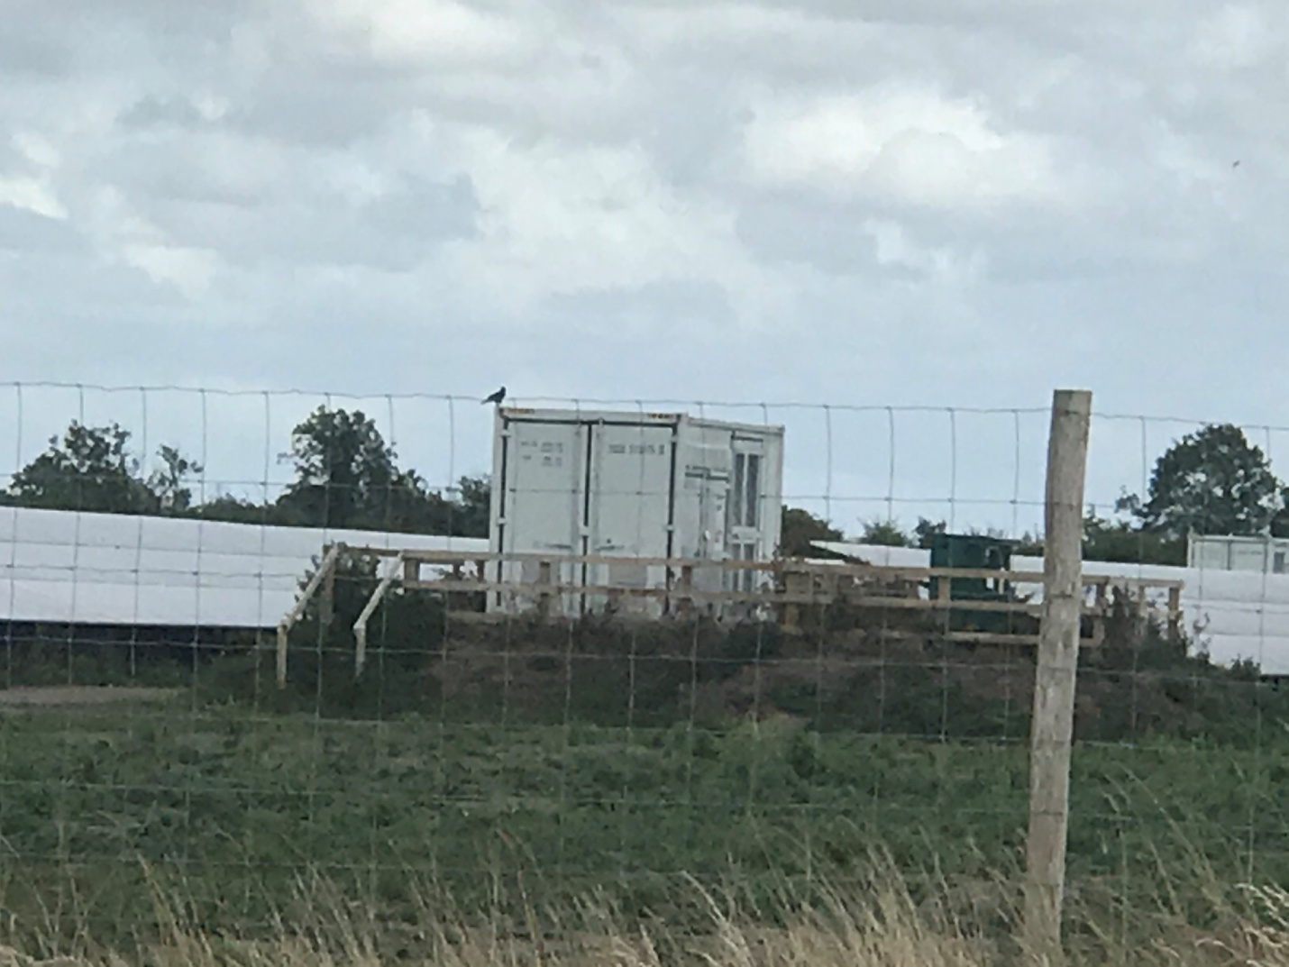
Battery container built up on earth bund Llanwern Solar Development 7th September 2022
Chapel Lane, Goldcliff.

