Marshfield Community Council

Presents a Free Talk for the residents of Marshfield and Castleton at Marshfield Village Hall

Newport Medieval Ship
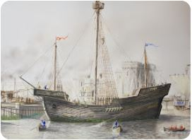
Friday 9th June 2023 @ 7.15pm

Dr Toby Jones archaeologist and project curator will give an illuminating talk about the mid -fifteenth- century sailing vessel discovered in June 2002 in Newport

Refreshments will be available from the Village Coffee Shop
Doors open at 6.45pm

