Serving the Communities of Castleton and Marshfield
Chairperson: Cath Davis
Clerk: Mr G C Thomas 4 Kenilworth Road Newport South Wales NP19 8JQ
Tel: 01633 375812 marshfieldcommunitycouncil@gmail.com

Marshfield Community Council Newsletter Summer 2023

Welcome to Marshfield Community Council’s Summer Newsletter (issue 5) and the first complete year of producing this publication to keep you all informed about the council’s work. MCC hope that all residents in Castleton and Marshfield are having a great summer despite the disappointing weather. MCC do not meet in August but will be back on 12th September, 10th October and 14th November.

Join Marshfield Community Council?
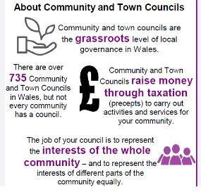
MCC currently have two vacancies for community councillors via cooption; becoming a councillor gives you a chance to serve and represent your community. Councillors make decisions on behalf of the community on various matters intending to make the lives of residents better. The role is rewarding, challenging and enjoyable and enables playing an important part in local democracy. The community council provides a bridge between the community and the local authority.

Marshfield Bus Campaign
Campaign Update – the bus group continues to work with our city councillors to achieve a scheduled bus service. The campaign has been halted by Newport City Council as they insist on an independent survey to determine if there is an appropriate demand from the community. This is despite the group consulting over 500 residents and 98% wanting a scheduled bus service. Further updates will be posted on social media and the MCC website as they arise.

Scarecrow Festival
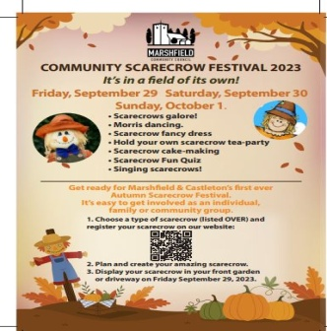
Marshfield Community Council’s first Scarecrow Festival will take place for three days over the weekend of Friday 29th and Saturday 30th of September and Sunday 1st October. This event is for the whole community to get involved whatever age, to make and display a scarecrow. Look out for this leaflet and the MCC website for full details on how to enter; there will be a facility on the website to enter online. Categories are traditional, funniest, friendliest, most surprising, scariest and most stylist scarecrow; certificates and rosettes for the winners!

Tredegar Park and Marshfield Ward
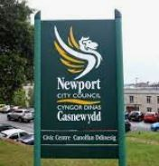
Your ward councillors Rhian Howells Rhian.Howells@newport.gov.uk , Allan Screen Allan.Screen@newport.gov.uk and Trevor Watkins Trevor.Watkins@newport.gov.uk will be holding the following surgeries:-
Friday 8th September at Michaelston Village Hall at 6.30pm
Friday 20th October at Duffryn Community Centre at 6.30pm
Friday 17th November at Marshfield Village Hall at 6.30pm
Friday 8th December at Peterstone Village Hall at 6.30pm
The above surgeries are an opportunity for you to speak directly to your representatives from Newport City Council on any matter affecting you.
Litter and Fly-tipping
This continues to be a nuisance in our villages. If you see fly-tipping happening please report on the Newport City Council phone app or the contact centre on 01633 656656 (daytime) and 01633 656657 (evening) or email info@newport.gov.uk – thanks to Marshfield Magpies and all those that do report fly-tipping and also litter pick to help keep our villages clean and tidy.

Enhancing and Protecting Nature
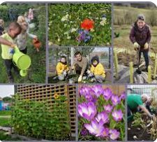
Welsh Government created ‘Local Places for Nature’ for community councils and other groups to obtain capital grant funding from various sources to enable communities in Wales to restore and enhance nature in their community. ‘One Voice Wales’ supports community councils and has a full time officer helping to obtain funding. MCC invited Rachel Carter to visit Marshfield on 7th August to help us identify areas where nature improvements can be achieved. This was a really good meeting and Rachel gave the council many ideas.
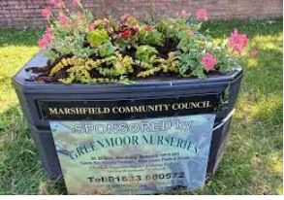
Village Planters 2023
Thank you to the generosity of Greenmoor Nurseries, St Brides for sponsoring our village planters again this year. The planters bring a splash of colour to our community throughout the summer. MCC also wishes to thank RMB Hydroseeding Ltd for filling the planter’s water reservoirs and the allotment water containers very generously free of charge.

Village Allotments
MCC is responsible for organising the two allotment sites in Marshfield Village. There are a few vacant plots available on the Marshfield Road site; if anyone is interested in growing their own fruit and vegetables please email marshfieldcommunitycouncil@gmail.co.uk for an application form and viewing

Marshfield Neighbourhood Watch
All details for the recently established Marshfield Neighbourhood Watch Scheme can be found by scanning the QR code on your smart phone or on the website below.
https://www.ourwatch.org.uk/scheme/170113/marshfield-south

