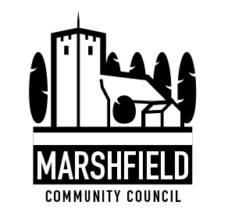
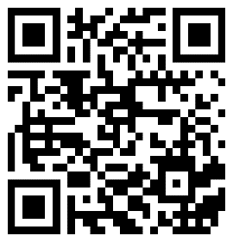

Serving the Communities of Castleton and Marshfield
Chairperson: Cath Davis
Clerk: Mr G C Thomas 4 Kenilworth Road Newport South Wales NP19 8JQ
Tel: 01633 375812 marshfieldcommunitycouncil@gmail.com

Marshfield Community Council Newsletter Autumn 2023
The clocks have changed and the evenings are darker as we go into the winter months, MCC welcome you to the latest edition of news and information from your community council. Don’t forget that the council meets on the second Tuesday of the month, 7.15pm at Marshfield Village Hall, this is an open meeting and everyone is welcome to attend. You can also contact the council on all the ways listed above.

Marshfield Scarecrow Festival
The first ever Marshfield Scarecrow Festival took place over the last weekend of September, the aim of the organisers was ‘to bring the community together through creativity, team-work and community engagement, involving various groups, teams and individuals’. It certainly did this with over 90 entries received on-line, it was a resounding success. The effort and ingenuity that went into making the scarecrows was absolutely brilliant and well done to all the deserving winners. Many thanks go to the main sponsor Greenmoor Nurseries along with Simpson Estates, The Masons Arms, Cardiff Garden Centre, Trade Price Tyres, Celtic Leathers Wales and ISCA Morris Dancers.

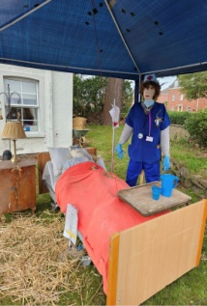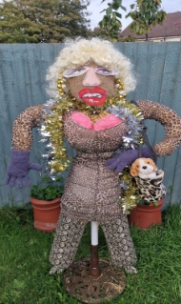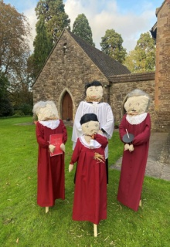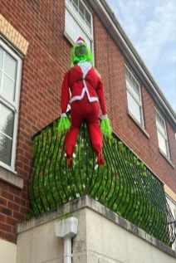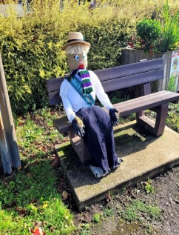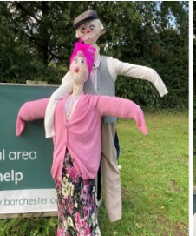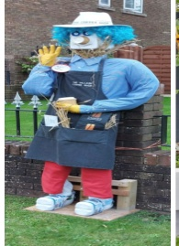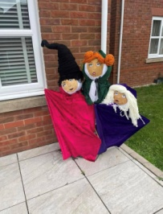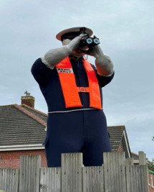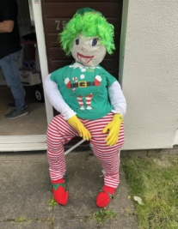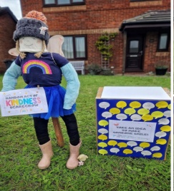

Just a few examples of the wonderful scarecrow entries received by the community council, other activities included ISCA Morris Dancers and a scarecrow themed quiz night both held at The Masons Arms.

Marshfield and District Women’s Institute are celebrating their 100th Birthday in 2024!!!
We meet twice a month, September through July, on the 1st and 3rd Tuesday @ 7.30pm at Castleton Village Hall. The WI provides women with fun and friendship plus the chance to learn new skills. We get involved with the community and take part in a wide range of activities. As we move into our centenary year – we are hosting many events to celebrate our 100th birthday – please watch out for details on Facebook and around the village. You’re always welcome and we’d be delighted to see you! Please contact us at marshfield18@gmail.com for more information.
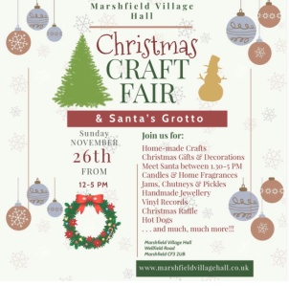
Christmas Craft Fayre at Marshfield Village Hall on Sunday 26th November at the village, 12 -5pm. Come and visit Santa in his grotto between 1.30 and 5pm. There will be home-made crafts, Christmas gifts and decorations, candles, home fragrances and much, much more. For full details visit www.marshfieldvillaghall.co.uk

The National Defibrillator Network –The Circuit
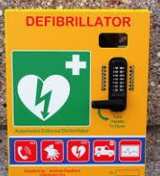
The Community Council is pleased to confirm that the defibrillator located outside Marshfield Village Hall is registered with the British Heart Foundation ‘The Circuit’ which is a centralised national database. This will ensure that it can be found quickly and easily in cases of emergency helping to improve survival rates from cardiac arrest in the UK www.bhf.org.uk.
Local Places for Nature Update
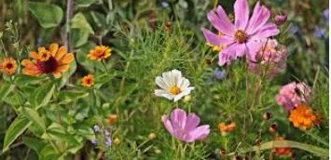
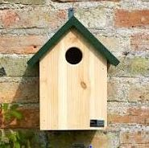
After consulting ‘Local Places for Nature’ Officer Rachel Carter, Marshfield Community Council is hoping to act upon a number of Rachel’s suggestions regarding ways we could improve local biodiversity and further enhance our natural environment. In order to proceed and qualify for some available grants, we have been advised that we will need to seek and encourage support from local groups and communities. Scouts, Guides and St Mary’s youth group have already expressed an interest in building and erecting bird and bat nesting boxes. If anyone else would like to volunteer as an individual or a group, to get involved with projects such as the instillation of a communal garden or other planting and growing projects please contact the council marshfieldcommunitycouncil@gmail.com

St Marys Church, Marshfield Events
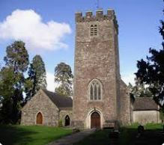
Sunday 19th November- Family Service with crafts and activities 10.30am
Friday 1st December - Community Candlelight and Carols 7pm, Christmas tree light switch-on kindly sponsored by Tovey Bros
Saturday 9th December - Christmas Fayre 10am
Sunday 17th December – Christingle Service 10.30am
Sunday 24th December – The Nativity 10.30am
Sunday 24th December – Midnight Mass 10.30pm

