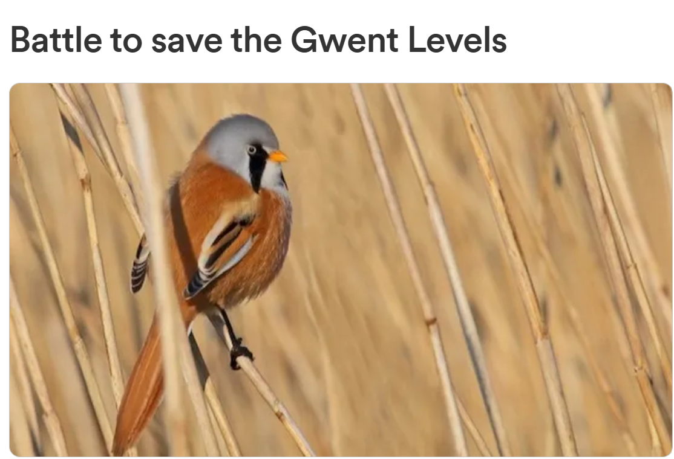
The Gwent Levels, a uniquely beautiful and historically significant area of South East Wales, is fighting for survival.

A fragile and complex wetland landscape reclaimed from the sea, much of it a designated Site of Special Scientific Interest, is home to a vast range of flora and fauna, including some of Britain's rarest bees.

But an increasing number of large-scale developers have set their sights on the Levels for commercial gain. At least seven major developments are in the planning pipeline which would bring about a loss of nearly 10% of the Gwent Levels SSSI.

Friends of the Gwent Levels formed in 2020 to protect the unique landscape and ecology of the Levels from damaging developments, and to ensure its survival for future generations; we need funds to help us fight the developers.

Our team of volunteers with a passion for the Levels is engaged in a David and Goliath battle with these big commercial developers who have resources to pay consultants and legal teams to secure their inappropriate planning applications.

We urgently need funds to engage legal and professional support to defeat the developers. Otherwise we may see commercial interests swiftly take over this ancient, special place, destroying one of the most precious and rare habitats in Wales.


Please visit www.gofundme.com and donate to our cause!

